Minutes of the General Meeting of the Comstock Grizzlies
Saturday May 18th @ 6:30 PM
Nathan and Ken’s Home

General information and attendance:

Meeting called to order @ 7:23 PM by President Ken

Meeting Attendee’s: Nathan, Ken, Dan, Tom,
Jason, Steve, Thomas, Max, Dean, Jim, Terry, Nick

Attendee’s: 12

March 2024 minutes were sent to group.

Motion to approve as sent.
Motion: Max Second Thomas, Approved by acclimation.

Current information for these minutes.
Treasurers Report: Through 05/18/24

Previous Balance: $ 481.81
Transactions: IN $ 00 .00
Transactions: OUT $ - 00.00
Ending Balance: $ 461.81
Net Change: $ + 00.00

Motion to approve Treasury.
Motion: Max Second Thomas, Approved by acclimation.

Although dues are not required to attend activities.
We are all encouraged to renew your dues
and look at friends to become members.
Just so we have funds for our club expenses.

Web/Facebook Report:
FULLY UPDATED

Old Business:

New Business:
The Annual Beer Bust and Meet and Greet is
Planned for Saturday June 15th from 3 – 6pm.
Max funds of $100 was approved for supplies
for the beer bust. Same as prior years.
Motion: Max, Second Thomas
Approved by acclimation.

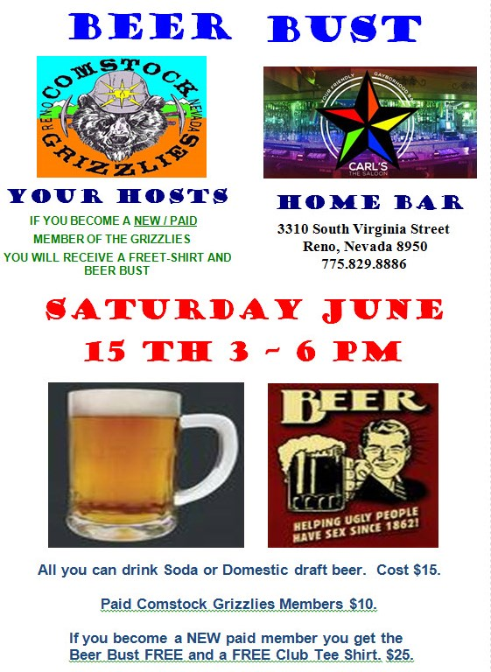

New business continued:

Planned Outing:
Magic Carpet Mini Golf
6925 S Virginia St, Reno, NV 89511
Wednesday June 12th @ 6:30 pm
Dinner Night Out – To be on 1st or 2nd Wednesday’s
of month. Club agreed to move DNO to Wednesdays.

Next DNO will be at:

Bertha Miranda's
336 Mill St, Reno, NV 89501
Wednesday June 8th @ 6:30 pm
Steve to reserve table.

Pot Luck Dinner and Club Meeting – Typically the 3rd
Saturday of the month

Next Meetings:

June Meeting:
To follow Beer Bust Meet and Greet.
Carl”s Saloon @6pm.

July Meeting:
Jim and Larry’s Home in Reno
Saturday July 20th @6:30pm

Hope to see you all there.

Close the meeting:
Motion: Max, Second Thomas
Approved by acclimation.
Approved at 7:35 PM.

Respectfully Submitted
Nathan C. Secretary
May 26th, 2024

